**Fun with Puzzles**

**EASY**

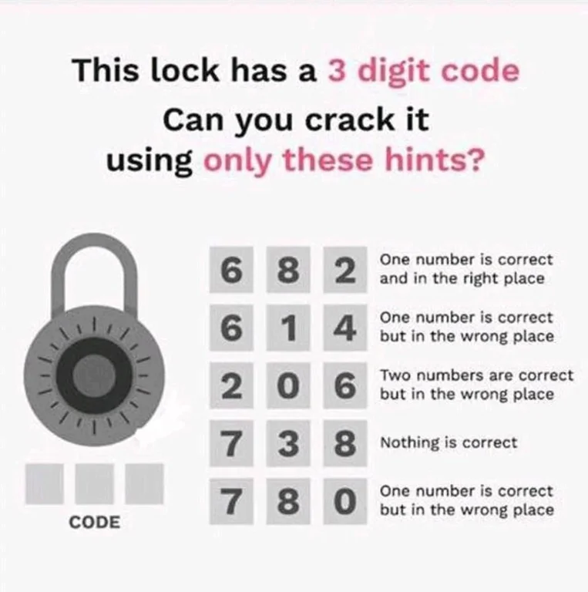

*Hint:* Start with the fourth hint, and now you know the combination doesn’t contain any of those numbers.

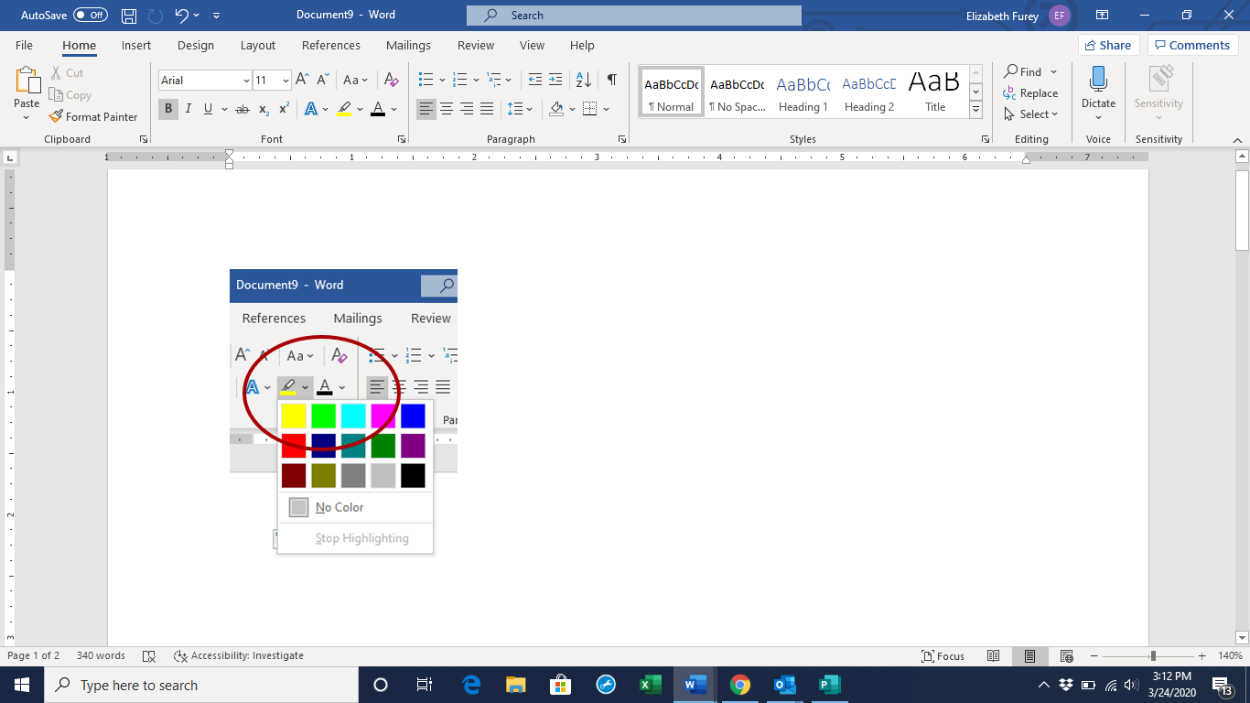

**MEDIUM**

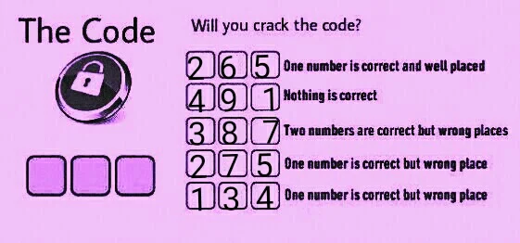

*Hint:* Again, start with the clue that nothing is correct. Then look at the fifth clue, then look at the third clue.

**HARD**

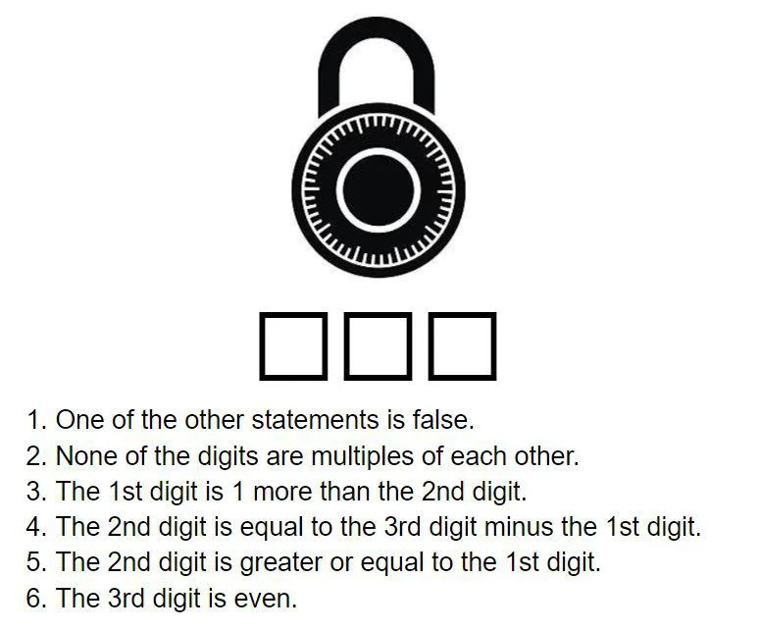

*Hint:* Clues 3 and 5 directly contradict each other, so clues 2, 4, and 6 must be true. Work from there to figure out which one of 3 and 5 are true.

**VERY HARD**

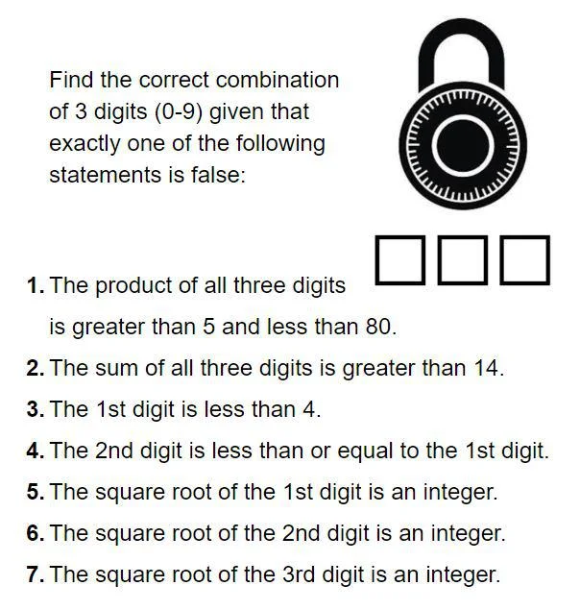

*Hint:* The numbers that would satisfy the last 3 clues are 1, 4, and 9. So you know that at least 2 out of the 3 numbers are either 1, 4, or 9 (but a number could be repeated).