**Fun with Puzzles**

**EASY**

Here is an ordinary cross. You are allowed to make two straight cuts across it.

How do you cut it to make the most pieces?



*Hint:* The maximum number of pieces you can make is 6. But how do you do that?



**MEDIUM**

You’re standing on the surface of the Earth. You walk one mile south, one mile west and one mile north. You end up exactly where you started. Where are you?

*Hint:* There is more than one answer to this puzzle, but for the simplest answer, your first step HAS to be south. This puzzle wouldn’t work by walking west, then south, then east for example.

**HARD**

Suppose you're on a game show, and you're given the choice of three doors: Behind one door is a car; behind the others, goats. You pick a door, say No. 1, and the host, who knows what's behind the doors, opens another door, say No. 3, which has a goat. He then says to you, "Do you want to pick door No. 2?"

Is it to your advantage to switch your choice?

*Hint:* The answer is not as simple as it seems. It would help to write out the possible scenarios.

**VERY HARD**

A week before Thanksgiving, a sly turkey is hiding from a family that wants to cook it for the holiday dinner. There are five boxes in a row, and the turkey hides in one of these boxes. Each night, the turkey moves one box to the left or right, hiding in an adjacent box the next day. Each morning, the family can look in one box to try to find the turkey.

How can the family guarantee they will find the turkey before Thanksgiving dinner?

*Hint:* If you simply search one box per day, starting with 1 and finishing with 5, you might not find the turkey. It could be in box 3 when you check box 2, and then move to 2 the next day when you check 3, and you would miss it. Similarly, you cannot keep checking the same box, as the turkey could bounce back and forth between only two boxes the entire time. You need a plan to guarantee you will find the turkey.

*Hint 2:* Have a plan for if the turkey is in an odd box and a plan if it is in an even box. Then try and combine your plans.

**ANSWERS:**

**EASY**

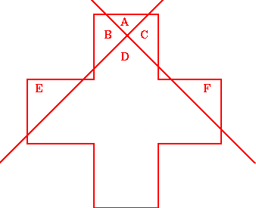

This is one of a few similar solutions. You should have been able to get 6 pieces!

**MEDIUM**

You were at the North Pole probably! Any direction you walk from the North Pole is south, so after walking 1 mile south, you then walk west for a mile. But you still haven’t traveled any further south from the North Pole, so your 1 mile walk back North nets you back at the North Pole where you started!

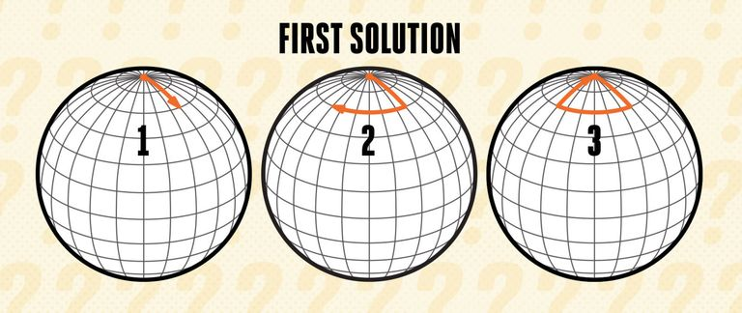

But there is a more nuanced solution to this problem as well. Imagine a circle with a 1-mile circumference that has the south pole at its center. If you were to start one mile north of this circle, you would travel one mile south, one mile west all the way around the circle, and then one mile north back to your starting point.

In fact, you could start anywhere that is one mile north of the circle around the south pole. (In the diagram, the orange circle has a 1-mile circumference, and you could start anywhere around the thick black latitude line.)

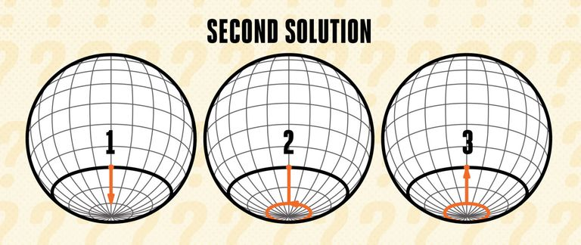

And the solutions don't stop there! With a little more math heavy approach, imagine that the circle around the south pole has a circumference of 1/2 mile instead of 1 mile. If you were to start one mile north of that 1/2-mile circle, you would travel one mile south, one mile west around the 1/2-mile circle twice, and then one mile north back to your starting position.

If the circle were 1/3-mile, you could still start one mile north of it, and you would travel around the circle three times. The same is true for any fraction 1/n where n is a positive integer, and the result is that you walk around the circle n times. If the circle around the south pole is only a tenth of a mile, you can still start one mile north of it, walk one mile south, one mile west around the circle ten times, and then one mile north back to your starting position.

So there are an infinite number of solutions technically!

**HARD**

This is the famous Monty Hall problem! Surprisingly, it is advantageous to switch your choice of doors. At first glance it seems like it’s a 50/50 chance whether your currently chosen door or the remaining closed door has the car. Writing out the possibilities reveals some interesting conditional probability.

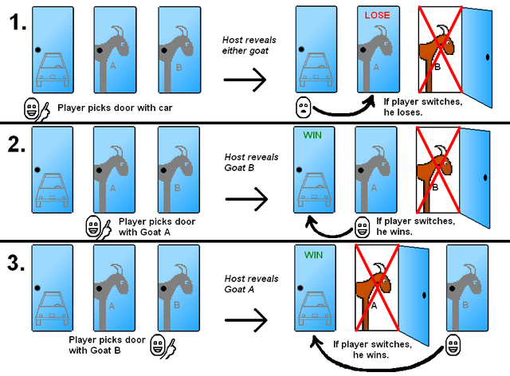

So, if you just pick a door at the beginning, and don’t change your answer, you have a 1 in 3 chance of winning. By not changing your answer, it is as if the host never revealed a goat behind another door, it’s just a simple 1 in 3 guess.

But you have a 2 in 3 chance of winning the car if you switch as illustrated by the graphic! Quite counterintuitive, is it not?

**VERY HARD**

Randomly searching will not guarantee you find the turkey. Neither will checking every box, nor will checking the same box over and over. To find this bird, we are going to have to make some assumptions.

First, for the sake of argument, let's assume the turkey is in an even-numbered box, meaning either box 2 or box 4.

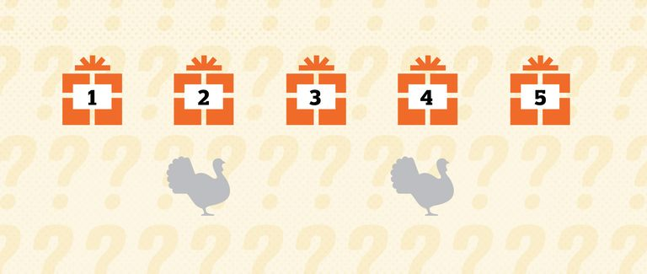

Let’s say you check box 2. If you find the turkey, all is well and good in the world and Thanksgiving can proceed. If not, then you know the turkey must have been in box 4 (again, this is based on an initial assumption that the turkey was in an even-numbered box).

If the turkey was in box 4 on the first day, when you checked box 2, then it must move to either box 3 or box 5 on the second day. So on the second day, check box 3. If the turkey is there, you win. If not, it must be in box 5, and if the turkey is in box 5 on the second day, it must move to box 4 on the third day, and so you check box 4 on the third day and find the turkey.

Now, the above scenario—checking box 2, 3, and then 4—will always let you win assuming the turkey started in an even-numbered box. But, of course, that might not be the case. Now let's look at the scenario if the turkey started in an odd-numbered box—1, 3, or 5.

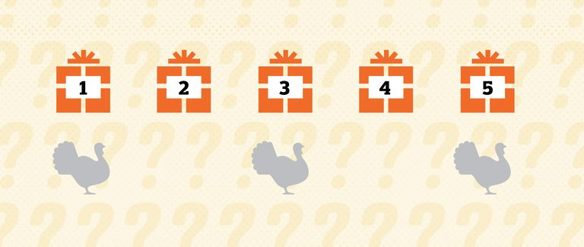

If the turkey is in box 1, 3, or 5, then on the second day, it must have moved to either box 2 or 4. On the third day, it must have moved back to box 1, 3, or 5. And on the fourth, the turkey again must have moved to either box 2 or 4.

You can probably sense we've discovered something important here: If the turkey started in an odd-numbered box, then after checking for three days, it must be in an even-numbered box. In other words, if the turkey started in an odd-numbered box, at the start of the fourth day, it must be in an even-numbered box. We now must combine the two scenarios.

First, we know from the first example that if you check box 2 and then 3 and then 4, you will find the turkey if it started in an even-numbered box. Let's say you check 2, 3, and 4 on the first three days, and you do not find the turkey. That means it must have started in an odd-numbered box, which also means that on the start of the fourth day, it must be in an even-numbered box. So, on the fourth day, if you have not found the turkey, you repeat the process, because you know that now it must be in an even box.

So here is the solution: Check box 2 on the first day, then 3 on the second day, and then 4 on the third day. If the turkey was in an even box, you are guaranteed to find it on one of those first three days. If you don't find it, then it must have started in an odd-numbered box, and on the start of the fourth day, it must be in an even-numbered box. So you then check box 2 on the fourth day, then box 3 on the fifth day, and finally box 4 on the sixth day. No matter what, you will have found the turkey.

In short: check box 2 then 3 then 4, and if you do not find the turkey, check box 2 then 3 then 4 again.